**Exercise 4: Functions**

**Scenario 1: Calculate the age of customers for eligibility checks.**

**PL/SQL Code:**

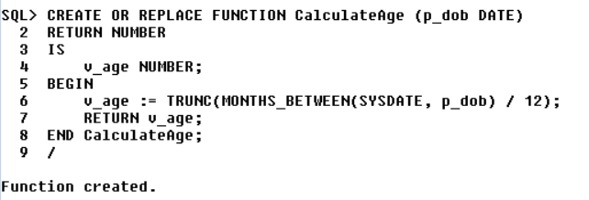

**Output:**

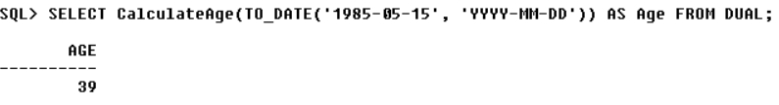

**Scenario 2: The bank needs to compute the monthly installment for a loan.**

**PL/SQL Code:**

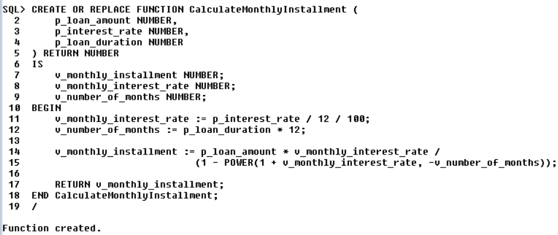

**Output:**

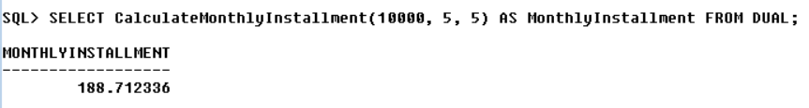

**Scenario 3:** **Check if a customer has sufficient balance before making a transaction.**

**PL/SQL Code:**

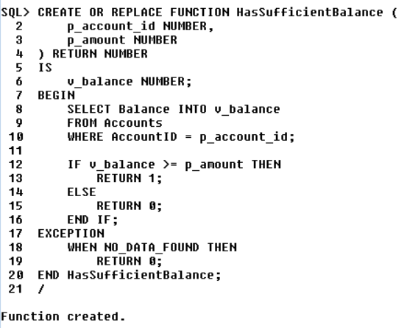

**Output:**

